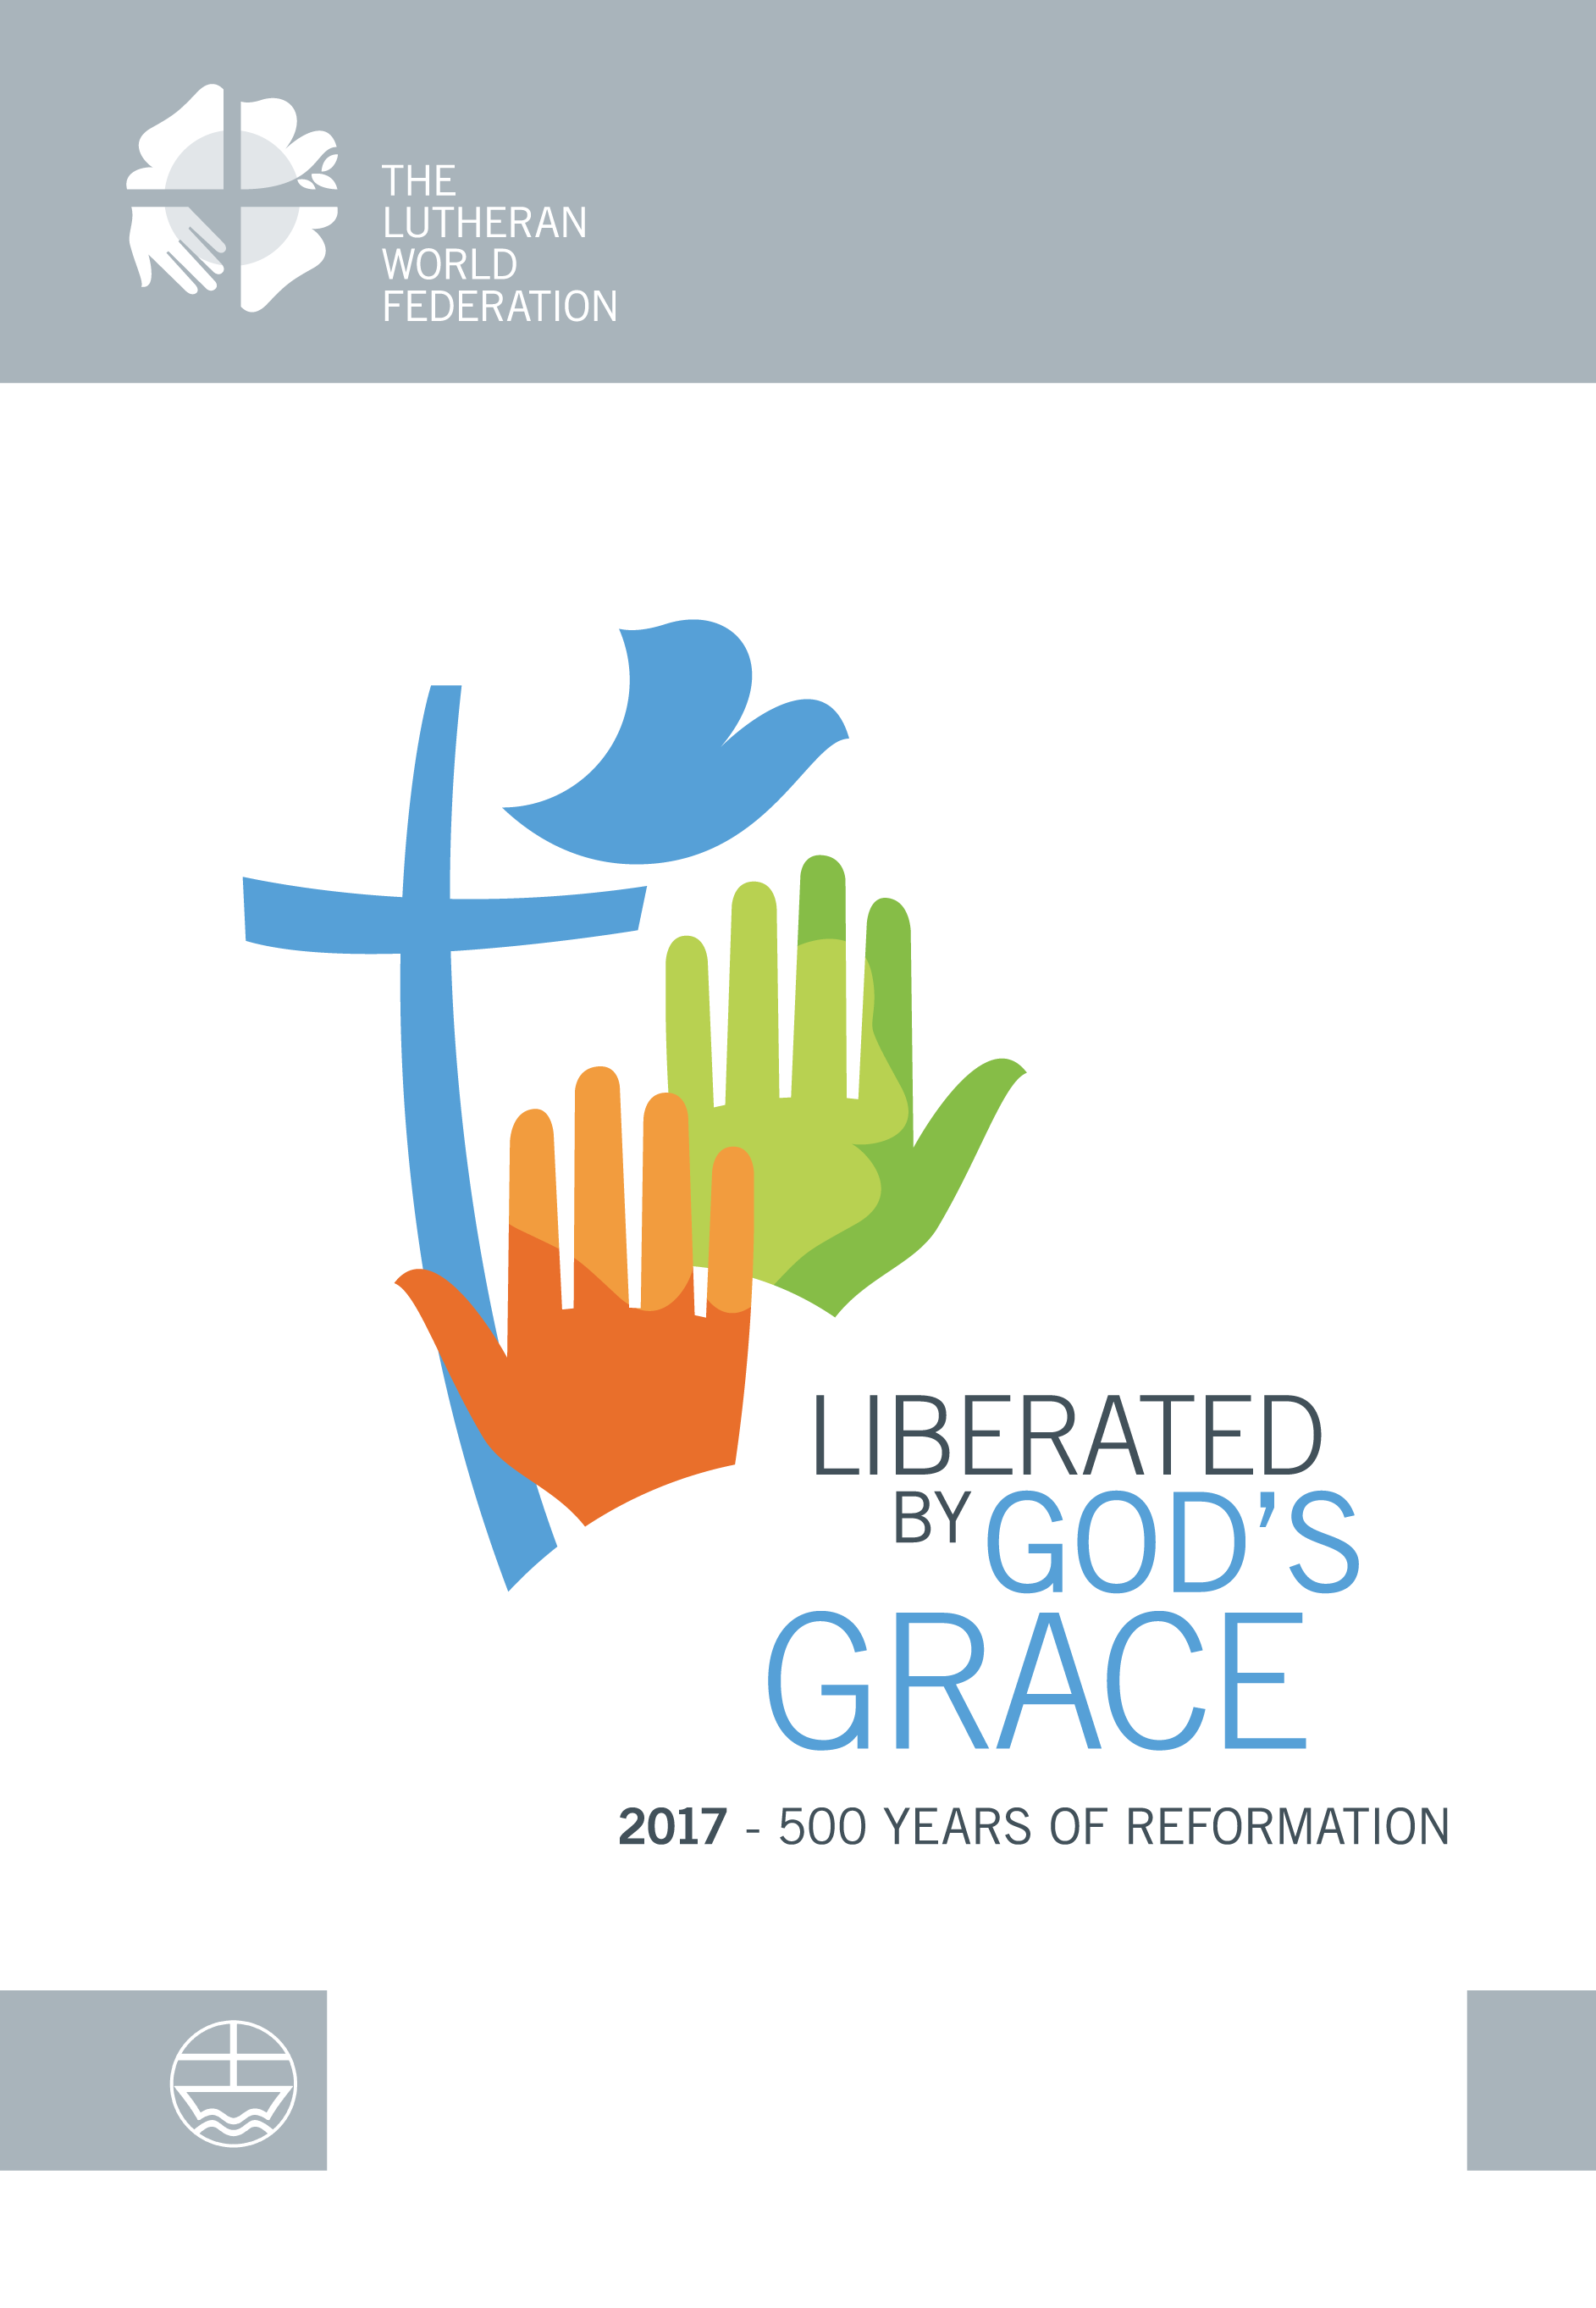

Liberated by God’s Grace
2017—500 Years of Reformation

Anne Burghardt

The Lutheran World Federation

A Communion of Churches
Department for Theology and Public Witness

ISBN: 978-3-374-04160--2
Price: € 19.90
Boxed set of four booklets
Available from

The Lutheran World Federation
Department for Theology and Public Witness

DTPWPublications@lutheranworld.org

THE BOOKLETS: In these four booklets, theologians from all parts of the world reflect on the main theme and three sub-themes (Liberated by God’s Grace: Salvation—Not for Sale; Human Beings—Not for Sale; Creation—Not for Sale) of the Lutheran World Federation’s commemoration of the 500th Anniversary of the Reformation. This collection of essays provides profound insights into the crucial issues and challenges daily faced by the members of the worldwide Lutheran communion in very diverse contexts. The theological concept of justification by God’s grace and its consequences for different dimensions of life serve as the main guiding principles for the essays, each one of which is accompanied by three questions that invite to further contextual reflection on the subject.

THE CONTRIBUTORS:
Liberated by God’s Grace: Gottfried Brakemeier; Elżbieta Byrtek; Hans-Peter Grosshans; Zephania Kameeta; Timothy J. Harris; Au Sze Ngui ; Kjell Nordstokke; Monica M. Villarreal
Salvation–Not for Sale: Busi Suneel Bhanu; Cristina Grenholm; Sarah Hinlicky Wilson; Jaan Lahe; Chiropafadzo Moyo; Elaine Neuenfeldt; Bernd Oberdorfer; Wolfgang Thönissen
Human Beings–Not for Sale: Ebise Dibisa Ayana; Gustavo Driau; Tamás Fabiny; Susan Johnson; Friederike Nüssel; Ulla Siirto; Douwe Visser; Munib A. Younan
Creation–Not for Sale: Naoki Asano; Elena Bondarenko; John Chryssavgis; Martin Kopp; Cibele Kuss; Stephen I. Munga; Ulrik Becker Nissen; Barbara R. Rossing.

THE EDITOR: Anne Burghardt is Secretary for Ecumenical Relations in Department for Theology and Public Witness (LWF) Geneva (Switzerland)

The Lutheran World Federation is a global communion of churches in the Lutheran tradition. Founded in 1947 in Lund, Sweden, the LWF now has 144 member churches in 98 countries all over the world, representing over 72 million Christians.

